The Federal Records & Information Management Forum
MARCH 16, 2015
RIM FORUM
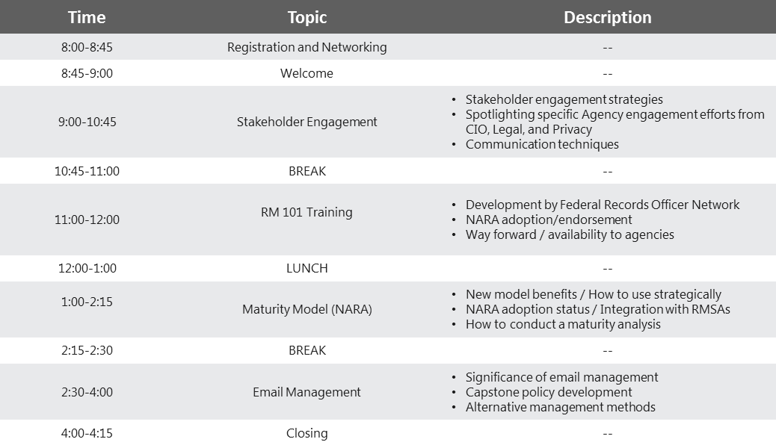

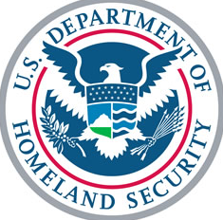
Registration closes Wednesday, March 11th.
To submit your registration form:
dhsrecordsmanagement@hq.dhs.gov

*Due to limited seating, registration is limited to Federal Staff only and is on a first-come, first-served basis.
I am planning to attend:
(Please choose one from below.)
☐ Full day ☐ Morning only ☐ Afternoon Only

NAME (Last, First, MI): Click here to enter text.
TITLE: Click here to enter text.
AGENCY/OFFICE: Click here to enter text.
E-MAIL: Click here to enter text.
PHONE: Click here to enter text.
REGISTRATION FORM*
Homeland Security

